A COMPREHENSIVE ANALYSIS OF FINANCIAL PERFORMANCE: INSIGHTS FROM A LEADING BANKS

1 .INTRODUCTION

1.1 Overview

The banking field has been transformed in the recend years . In order to know me growth of Banks we have developed this project by analysing the growth of various banks we can we this to analyse the growth of banks by comparing with the previous years performance.

1.2 Purpose

This project can be used to analyse the bank related data and extract some insights from the data of Banks for taking actions for the improvement of their performance

2. PROBLEM DEFINITION & DESIGN THINKING

2.1 Empathy Map

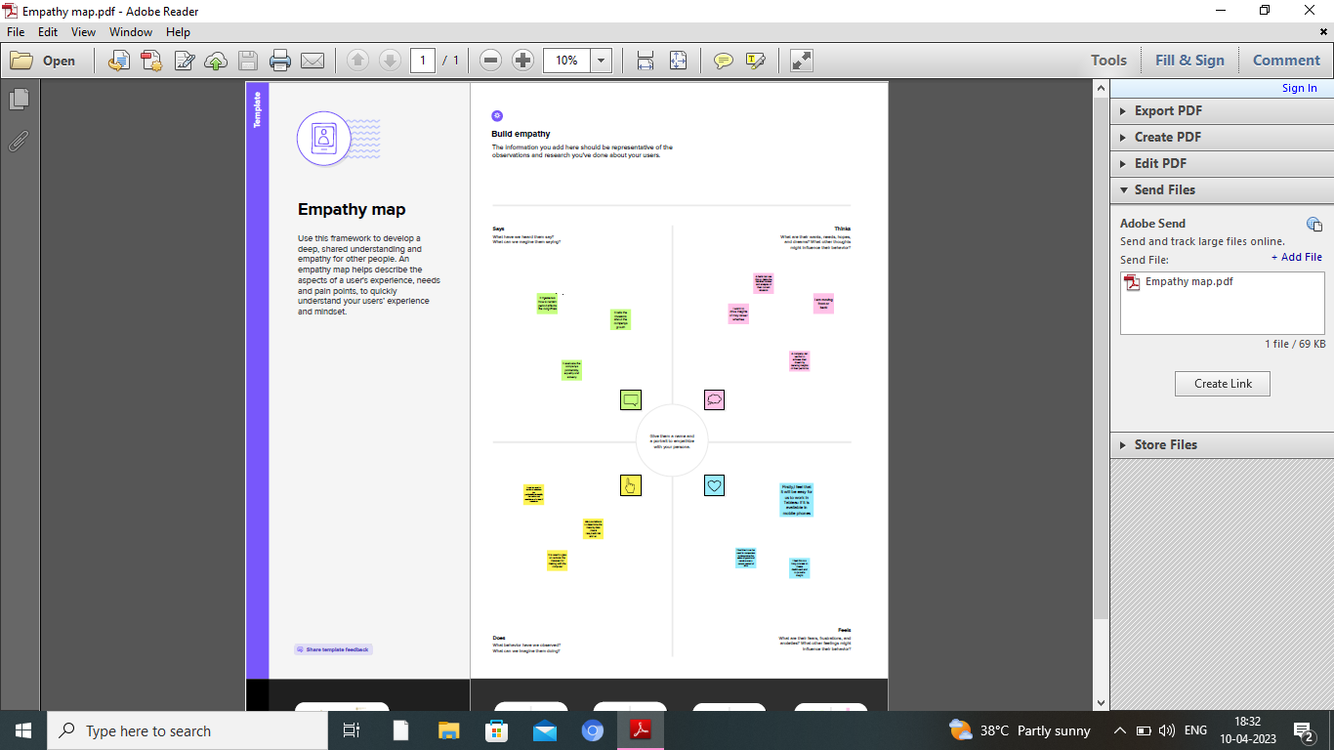

2.2 Ideation & Brainstorming Map

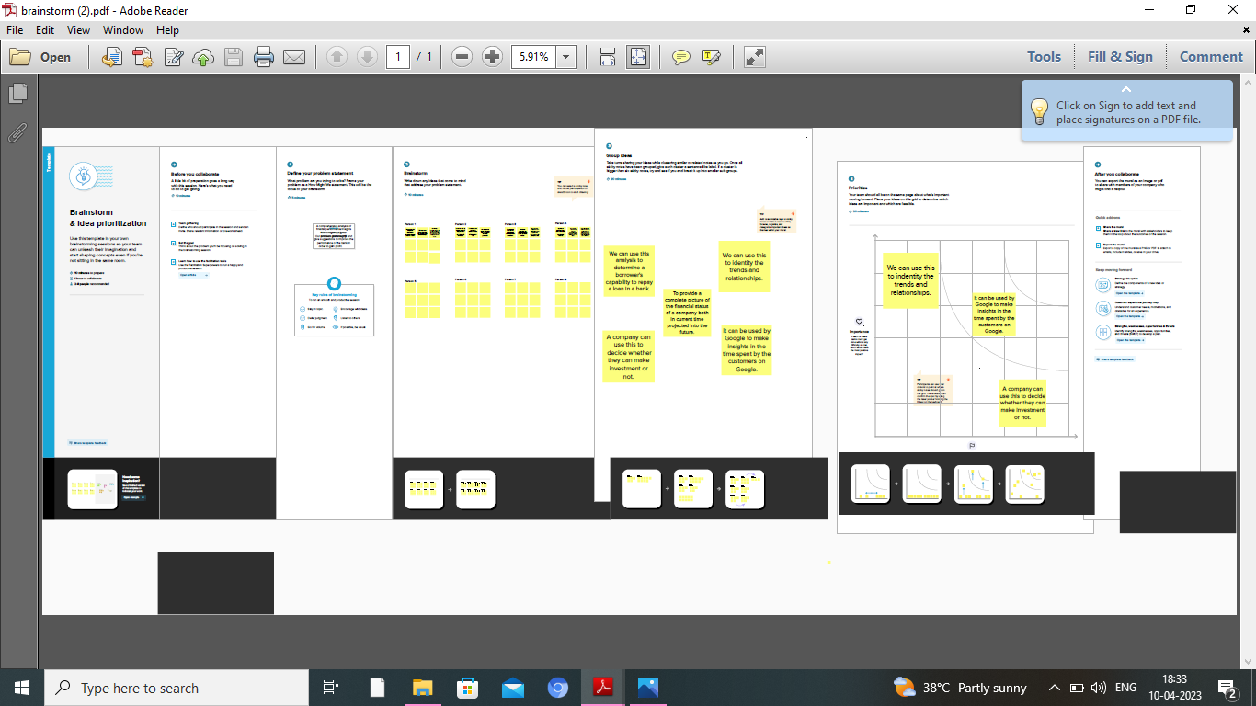

3. RESULT

Dashboard: 1

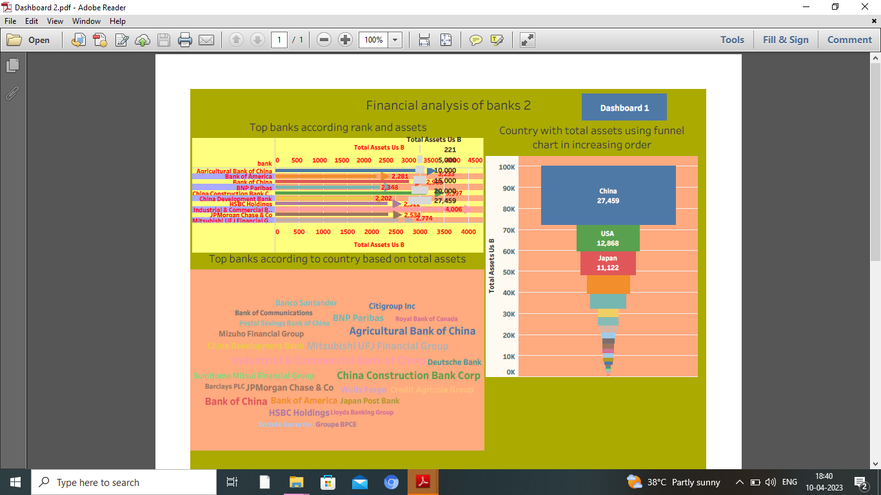

Dashboard:2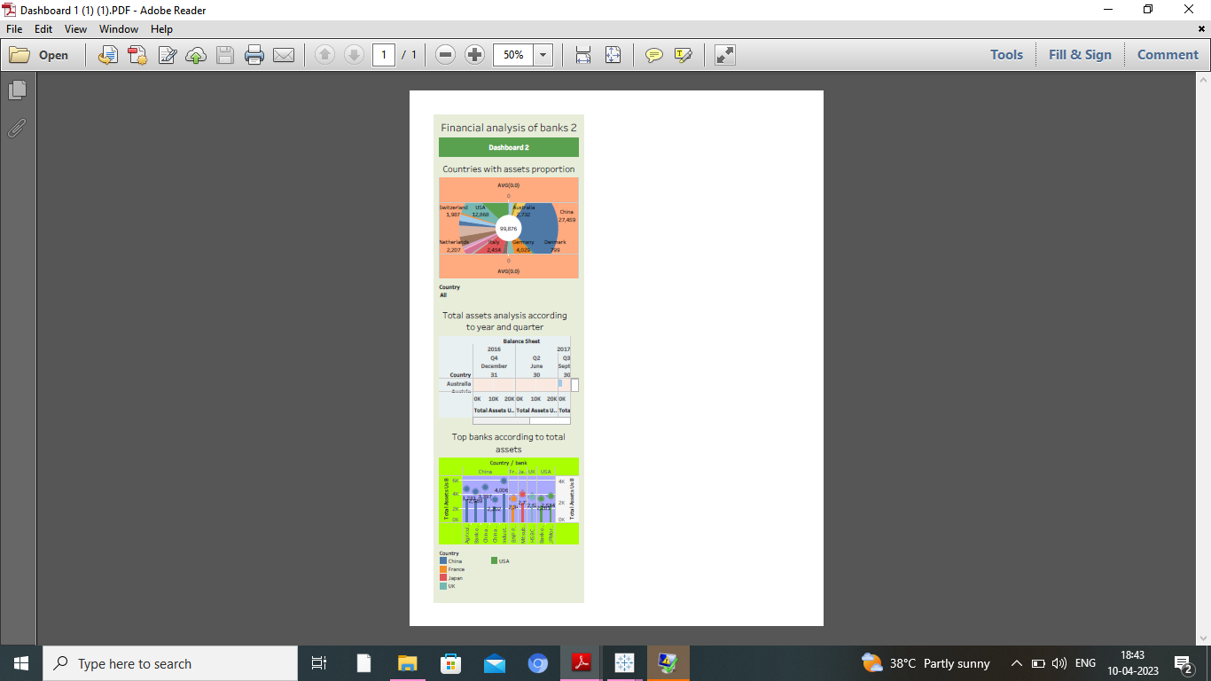

Story: 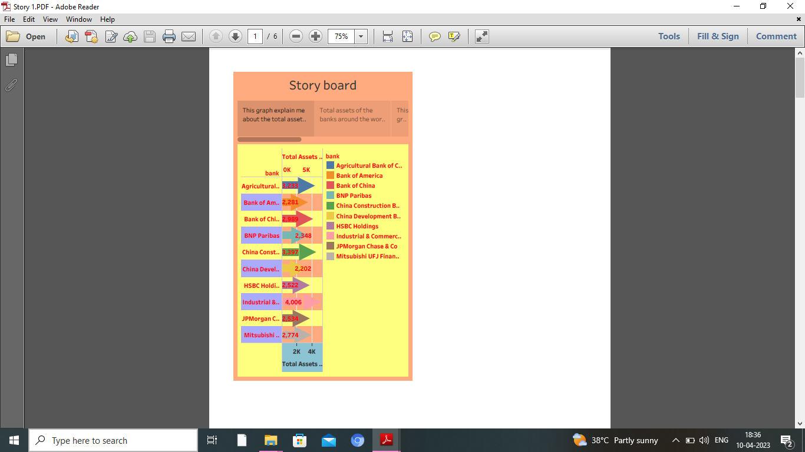

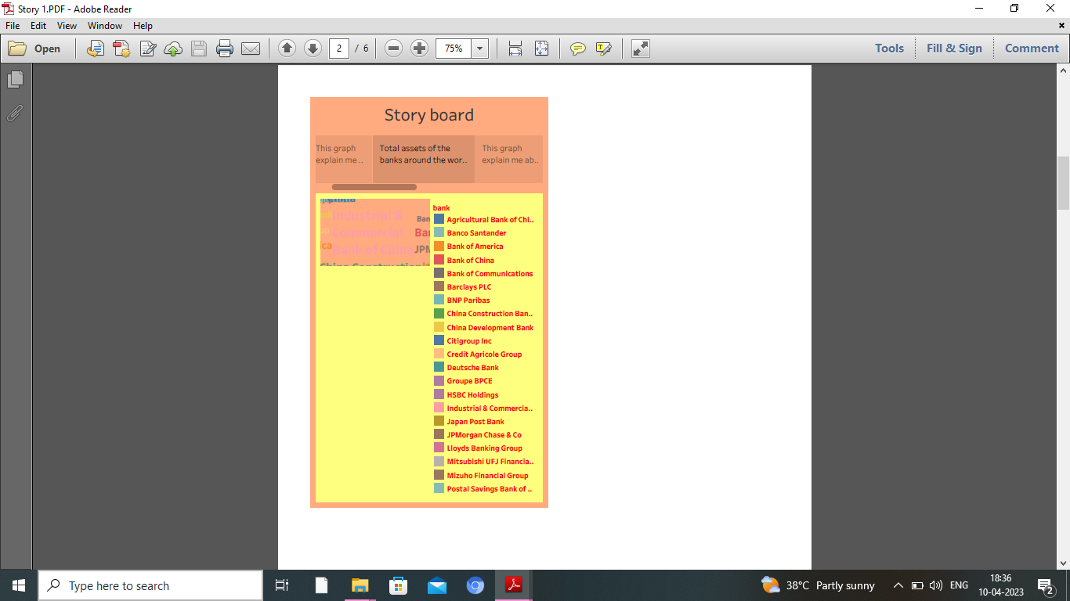

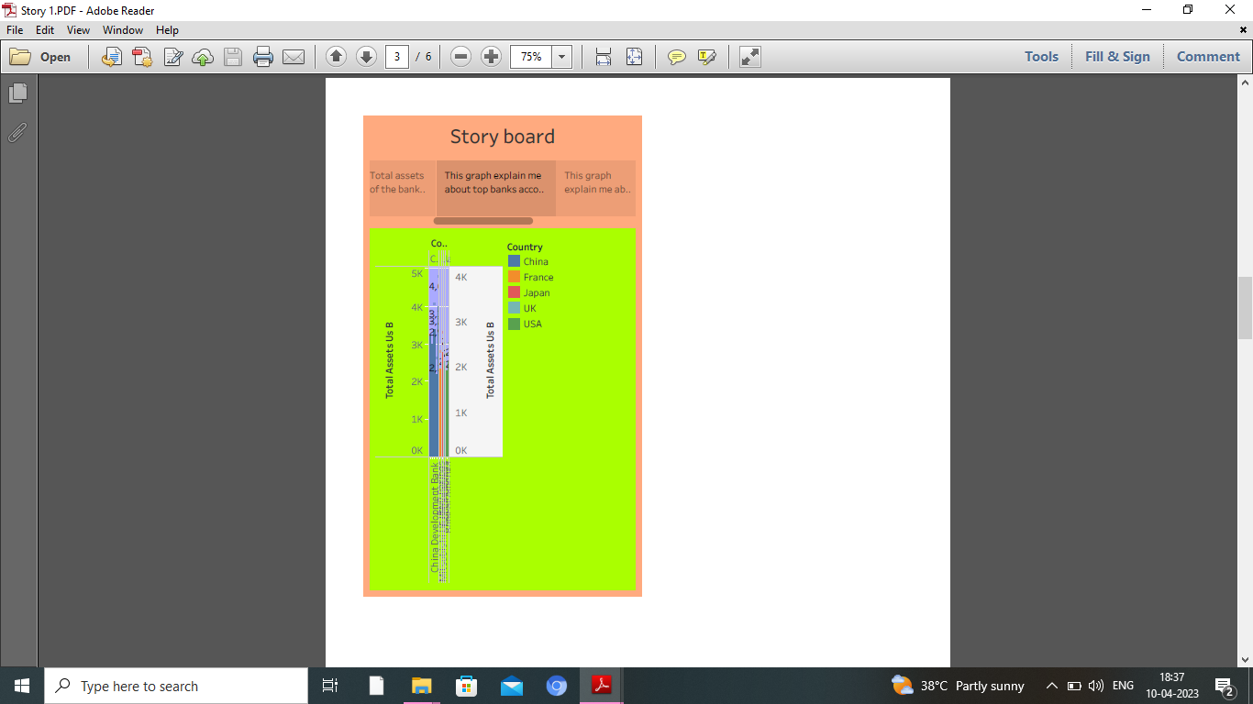

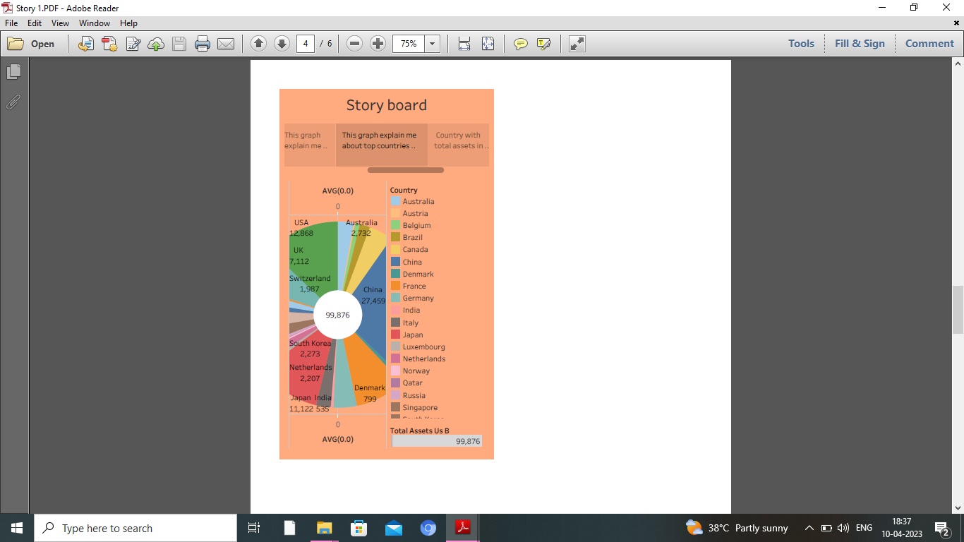

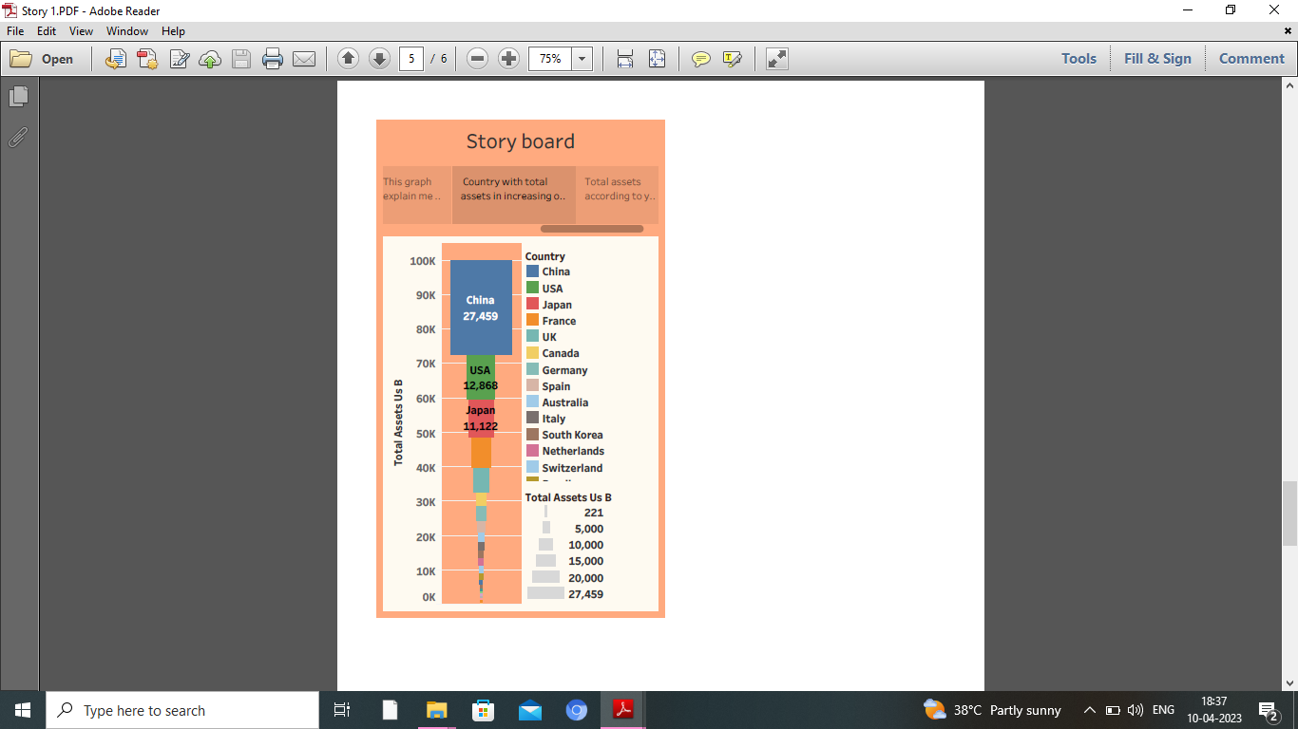

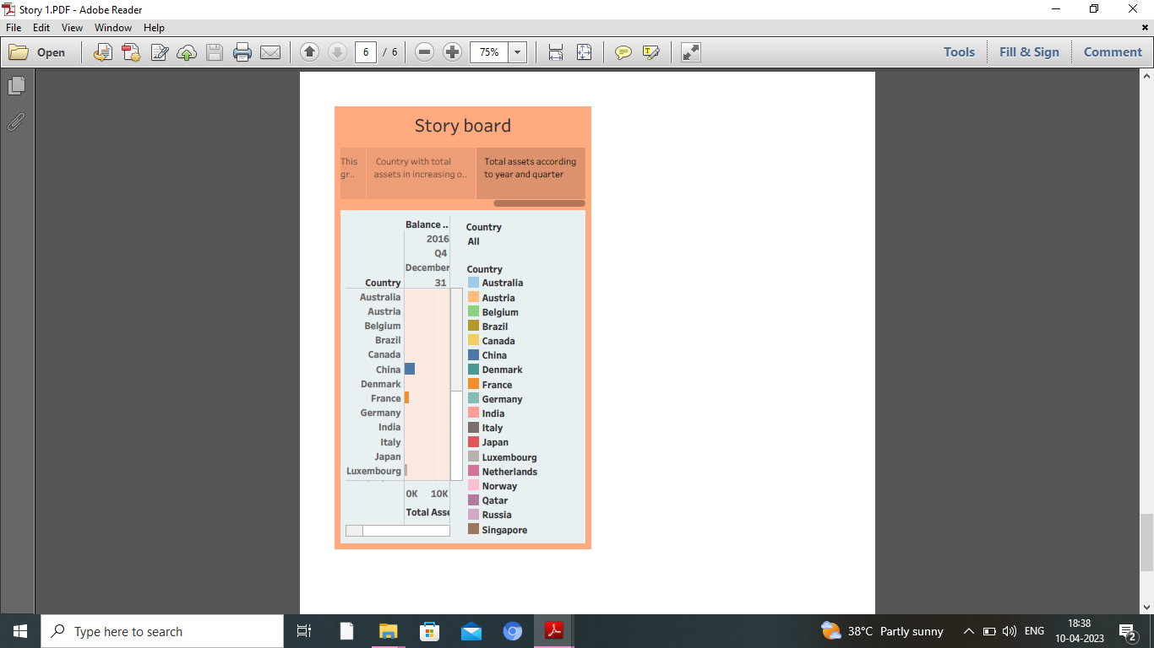

4. ADVANTAGES & DISADVANTAGES

ADVANTAGES :

It can be used to derive insights which is very easy for us to know the level of growth in each area.

DISADVANTAGES :

The only disadvantage what we feel is it is a long way process in finding insights.

5. APPLICATIONS

It can be used in Banking sectors. Also, it can be used in Hotels and Super markets to know their growth and compare it with other industries.

6. CONCLUSION

It is a process of comparing a company’s performance with other ones . It can also be used to know where the company has made high investment and also to know the loss in which sector.

7. FUTURE SCOPE

It has a great scope in the upcoming years inorder to know the growth and loss in each sector of the company

Since the world is growing electronically, it will definitely grow in the future.